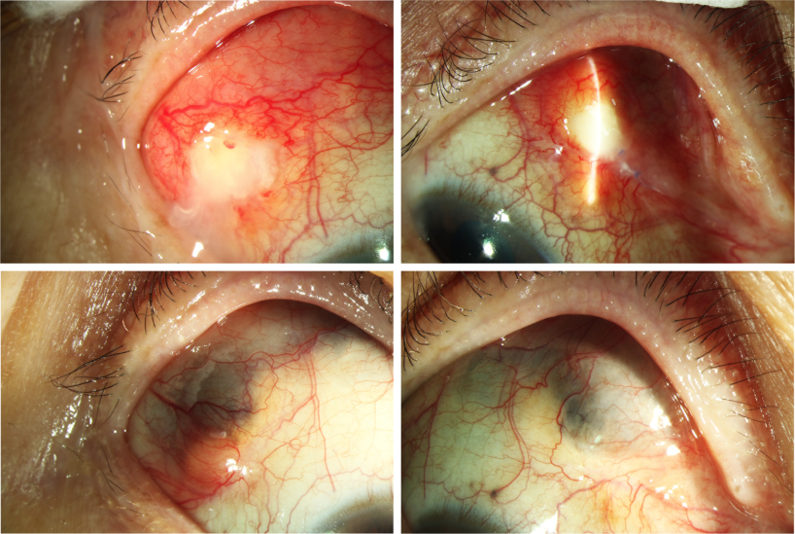

A 62-year-old woman with lung cancer treated with crizotinib was referred for subconjunctival masses in her right eye 3 years later.Examination revealed 2 whitish necrotic areas superonasally and superotemporally with localized injection and edema (A and B). After acomprehensive work-up excluding infection, autoimmunity, and metastasis, necrotising scleritis was diagnosed. Topical tacrolimus,tobramycin/dexamethasone, and lubrication significantly halted scleral thinning and promoted recovery (C and D). Subsequently,contralateral iridocyclitis occurred, which regressed after topical tacrolimus, steroid, and decongestive eyedrops. Based on the provided images and clinical description please make an ophthalmic diagnosis for this patient. And output the diagnostic conclusions only.

**Necrotising scleritis**